**1)**

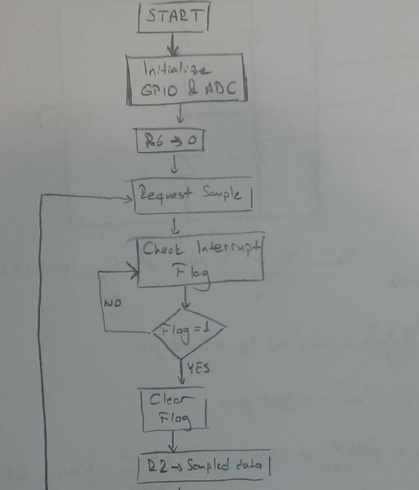

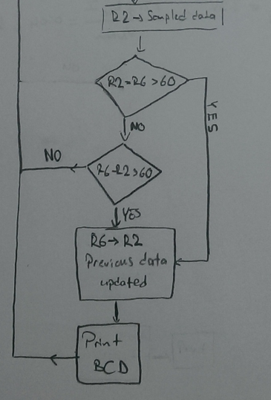

**2-3-4)**

**ADC & GPIO Initialization Subroutine**

; ADC Registers

RCGCADC EQU 0x400FE638 ; ADC clock register

;ADC0 base address EQU 0x40038000

ADC0_ACTSS EQU 0x40038000 ; Sample sequencer (ADC0 base address)

ADC0_RIS EQU 0x40038004 ; Interrupt status

ADC0_IM EQU 0x40038008 ; Interrupt select

ADC0_EMUX EQU 0x40038014 ; Trigger select

ADC0_PSSI EQU 0x40038028 ; Initiate sample

ADC0_SSMUX3 EQU 0x400380A0 ; Input channel select

ADC0_SSCTL3 EQU 0x400380A4 ; Sample sequence control

ADC0_SSFIFO3 EQU 0x400380A8 ; Channel 3 results

ADC0_PP EQU 0x40038FC4 ; Sample rate

; GPIO Registers

RCGCGPIO EQU 0x400FE608 ; GPIO clock register

;PORT E base address EQU 0x40024000

PORTE_DEN EQU 0x4002451C ; Digital Enable

PORTE_PCTL EQU 0x4002452C ; Alternate function select

PORTE_AFSEL EQU 0x40024420 ; Enable Alt functions

PORTE_AMSEL EQU 0x40024528 ; Enable analog

PORTE_DIR EQU 0x40024400 ;Set direction

AREA routines, CODE, READONLY

THUMB

EXPORT Initialize

;EXTERN OutChar

Initialize PROC

; Start clocks for features to be used

LDR R1, =RCGCADC ; Turn on ADC clock

LDR R0, [R1]

ORR R0, R0, #0x01 ; set bit 0 to enable ADC0 clock

STR R0, [R1]

NOP

NOP

NOP ; Let clock stabilize

LDR R1, =RCGCGPIO ; Turn on GPIO clock

LDR R0, [R1]

ORR R0, R0, #0x10 ; set bit 4 to enable port E clock

STR R0, [R1]

NOP

NOP

NOP ; Let clock stabilize

; Setup GPIO to make PE3 input for ADC0

; Enable alternate functions

LDR R1, =PORTE_AFSEL

LDR R0, [R1]

ORR R0, R0, #0x08 ; set bit 3 to enable alt functions on PE3

STR R0, [R1]

LDR R1, =PORTE_DIR

LDR R0, [R1]

BIC R0, R0, #0x08 ; set bit 3 to input for PE3

STR R0, [R1]

; PCTL does not have to be configured

; since ADC0 is automatically selected when

; port pin is set to analog.

; Disable digital on PE3

LDR R1, =PORTE_DEN

LDR R0, [R1]

BIC R0, R0, #0x08 ; clear bit 3 to disable analog on PE3

STR R0, [R1]

; Enable analog on PE3

LDR R1, =PORTE_AMSEL

LDR R0, [R1]

ORR R0, R0, #0x08 ; set bit 3 to enable analog on PE3

STR R0, [R1]

; Disable sequencer while ADC setup

LDR R1, =ADC0_ACTSS

LDR R0, [R1]

BIC R0, R0, #0x08 ; clear bit 3 to disable seq 3

STR R0, [R1]

; Select trigger source

LDR R1, =ADC0_EMUX

LDR R0, [R1]

BIC R0, R0, #0xF000 ; clear bits 15:12 to select SOFTWARE

STR R0, [R1] ; trigger

; Select input channel

LDR R1, =ADC0_SSMUX3

LDR R0, [R1]

BIC R0, R0, #0x000F ; clear bits 3:0 to select AIN0

STR R0, [R1]

; Config sample sequence

LDR R1, =ADC0_SSCTL3

LDR R0, [R1]

ORR R0, R0, #0x06 ; set bits 2:1 (IE0, END0)

STR R0, [R1]

; Set sample rate

LDR R1, =ADC0_PP

LDR R0, [R1]

ORR R0, R0, #0x01 ; set bits 3:0 to 1 for 125k sps

STR R0, [R1]

; Done with setup, enable sequencer

LDR R1, =ADC0_ACTSS

LDR R0, [R1]

ORR R0, R0, #0x08 ; set bit 3 to enable seq 3

STR R0, [R1] ; sampling enabled but not initiated yet

BX LR;

ENDP

END

**Main Code**

ADC0_RIS EQU 0x40038004 ; Interrupt status

ADC0_SSFIFO3 EQU 0x400380A8 ; Channel 3 results

ADC0_PSSI EQU 0x40038028 ; Initiate sample

ADC0_ISC EQU 0x4003800C ; ISC

;LABEL DIRECTIVE VALUE COMMENT

AREA main, READONLY, CODE

THUMB

IMPORT Initialize; Initialize subroutine

IMPORT OutChar;

EXPORT __main ; Make available

__main

BL Initialize; GPIO & ADC initialized

MOV R6,#0;

getsample LDR R1,=ADC0_PSSI; request a sample

LDR R2,[R1];

ORR R2,R2,#0x08; get a sample

STR R2,[R1];

loop LDR R1,=ADC0_RIS; check for interrupt flag

LDR R2,[R1];

ANDS R2,#0x08;

BEQ loop

LDR R1,=ADC0_ISC; clear the interrupt flag

LDR R2,[R1];

ORR R2,#0x08;

STR R2,[R1]; Interrupt flag is cleared

LDR R1,=ADC0_SSFIFO3;

LDR R2,[R1]; R2 is the data

SUB R0,R2,R6; check sampled data - previous > 0.05

CMP R0,#60;

BGT move;

SUB R0,R6,R2;

CMP R0,#60; check previous - sampled data > 0.05

BLT getsample;

move MOV R6,R2;

MOV R0,#1241; get the first digit

UDIV R1,R2,R0;

MOV R5,R1;

ADD R5,R5,#0x30; ascii conversion

PUSH{R0,R1,R2}

BL OutChar; print

POP{R0,R1,R2}

MOV R5,#0x2E; for '.'

PUSH{R0,R1,R2}

BL OutChar; print

POP{R0,R1,R2}

MUL R1,R1,R0;

SUB R2,R2,R1; R2 is newed

MOV R0,#124; get the second digit

UDIV R1,R2,R0;

MOV R5,R1;

ADD R5,R5,#0x30; ascii conversion

PUSH{R0,R1,R2}

BL OutChar; print

POP{R0,R1,R2}

MUL R1,R1,R0;

SUB R2,R2,R1; R2 is newed

MOV R0,#12; get the last digit

UDIV R1,R2,R0;

MOV R5,R1;

ADD R5,R5,#0x30; ascii conversion

PUSH{R0,R1,R2}

BL OutChar; print

POP{R0,R1,R2}

MOV R5,#0x0D; for new line

PUSH{R0,R1,R2}

BL OutChar; print

POP{R0,R1,R2}

B getsample;

ALIGN

END